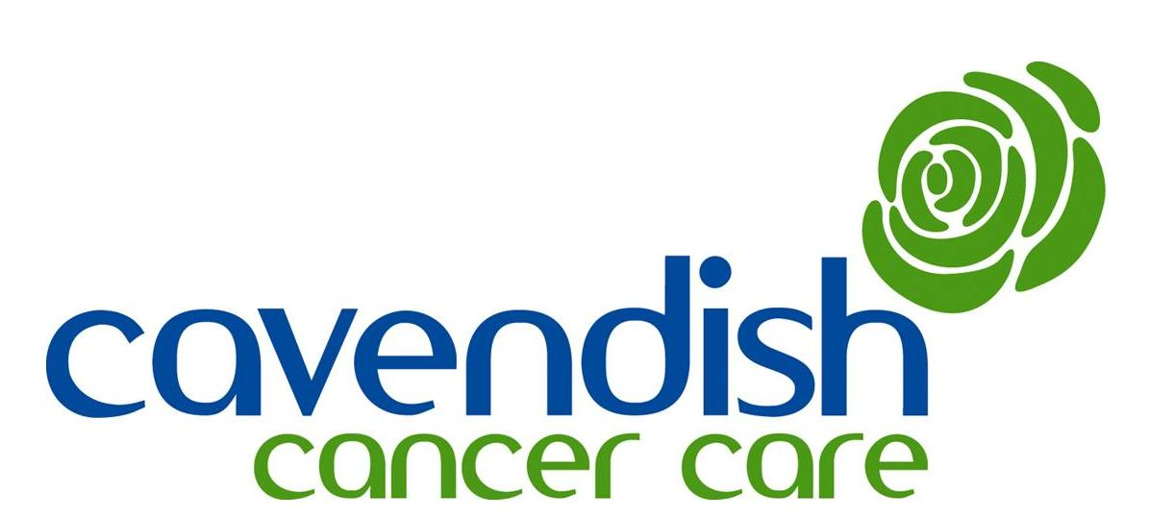

Work with Children and Young People at
Cavendish Cancer Care – an overview

Cavendish Cancer Care has supported adults with cancer and their carers since 1991 and in 2001 this service was extended to children and young people. The therapists responsible for this area of our work have many years experience of working with children and families. When parents or guardians first make contact, seeking help and advice about their children, they are generally contacted by phone for initial discussion and assessment. This is then usually followed by further face to face sessions at the Centre.

The children and young people come to us talk about how it affects them when a parent or someone else important to them has cancer or has died from cancer. While many children’s immediate needs are met by a few sessions, in which they can talk openly about their worries, the on-going uncertainty of cancer or the trauma of early bereavement may cause more complex difficulties for some children. We aim to offer short term support, which can be accessed again when needed, but sometimes children need to know that support is there for them over a longer period and we try to offer this too.

Parents generally come to talk through concerns they have about how their child is coping or about how to explain difficult truths to them. We also see the parents of seriously ill children who have cancer and help to support them through the painful time of treatment, terminal care or bereavement.

Lesley Neal
Children and Young People’s Therapist
2015

